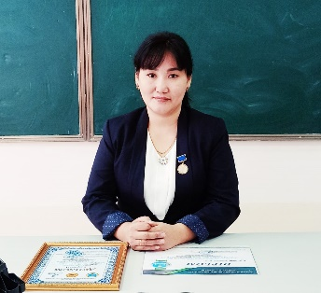

**ҚАНЫБЕКОВА Айгуль Боранбаевна,**

**Сағадат Нұрмағамбетов атындағы №72 жалпы орта білім беретін мектебінің ағылшын тілі пәні мұғалімі.**

**Шымкент қаласы**

**BUYING A GADGET**

|  |  |  |  |  |  |
| --- | --- | --- | --- | --- | --- |
| **Learning objectives(s) that this lesson is contributing to** | | 8.1.1.1 use speaking and listening skills to solve problems creatively and cooperatively in groups;  8.2.2.1 understand with little or no support most specific information in extended talk on a wide range of general and curricular topics. | | | |
| **Lesson objectives** | | - to expand and generalize the knowledge of students on the topic of “Gadgets”  - improving the skills of using vocabulary, speaking, and listening skills. | | | |
| **Plan** | | | | | |
| **Planned timings** | **Teacher’s activities** | | **Pupil’s activities** | **Marks** | **Resources** |
| **Beginning the lesson** | The lesson greeting.  The teacher sets the lesson objectives, letting students know what to anticipate from the lesson  Warm-up.  What do you think? What is our topic today? | | Students respond to the greeting  Ss answer the questions | Formative assessment is held through observation/monitoring.  Emoticon | <https://www.youtube>.  com/watch?v  =0OzrpzmboTk |
| **Main Activities** | **To present new vocabulary**  Digital camera  E-book reader  MP3 player  TV-set  DVD player  Radio recorder  Headphones  Laptop  Mobile phone  Robot pet  **Speak about favourite gadgets**  What's your favourite gadget?  What do you use it for?  What kind of gadget do you own?  **What are used for...? Complete the phrases using ... is used for...**  Explain the task. Remind Ss to use a dictionary and identify. Check answers.  **Advantages (positive) and disadvantages (negative) of using gadgets**  The teacher distributes leaflets with the advantages and disadvantages of gadgets.  **SWOT analysis**  gives students a poster and protects them with SWOT analysis  Method of Plickers  assesses students with questions | | Students think critically, exploring, developing, evaluating and making choices about their own and others’ ideas  A learner:   * selects an appropriate answer. * completes the task. * uses appropriate subject-specific vocabulary while speaking.   Learners match the words with the definitions, other learners match the words with translations.  Students think critically, exploring, developing, evaluating and making choices about their own and others’ ideas  Learners can write their ideas on a poster and then hang it on the wall. | Descriptor:  - show the gadget  -speak about a gadget  Descriptor:  - match the sentence  - find meaning  Descriptor:  -determine the advantages or disadvantages of the gadget  Descriptor:  -analyze and protect about topic  Descriptor:  -answer the questions | Handouts with task    Plickers QR code |
| **Ending the lesson** | **Reflection**  Thinking bubble  What was easy?  What was hard?  What did I learn?  How will you use in the future?  **Hometask:** Ex:7,pg38,St.b.  Make your own advertisement for a gadget  **Saying goodbye** | |  | Self-assessment |  |